**DAILY ONLINE ACTIVITIES SUMMARY**

|  |  |  |  |  |  |  |  |  |
| --- | --- | --- | --- | --- | --- | --- | --- | --- |
| **Date:** | **24-6-2020** | | | | | **Name:** | **Poojashree T** | |
| **Sem & Sec** | **8th sem B sec** | | | | | **USN:** | **4al16cs064** | |
| **Online Test Summary** | | | | | | | | |
| **Subject** | | **No Test** | | | | | | |
| **Max. Marks** | |  | | **Score** | | |  | |
| **Certification Course Summary** | | | | | | | | |
| **Course** | **Introduction to R language tutorial** | | | | | | | |
| **Certificate Provider** | | | **Great learning academy** | | **Duration** | | | **3.0hr** |
| **Coding Challenges** | | | | | | | | |
| **Problem Statement:** **1**. **to read the number and compute the series.**  **2. to count the number in th series.**  **3. to check whether number is palindrome or not.**  **4. to find the number between 0 and 50 which are not divisible by 2 and 3.**  **5.micro and array update**  Top of Form | | | | | | | | |
| **Status:completed** | | | | | | | | |
| **Uploaded the report in Github** | | | | | **yes** | | | |
| **If yes Repository name** | | | | | **Poojatgowda** | | | |
| **Uploaded the report in slack** | | | | | **yes** | | | |

**Online test**

No Test

**Certification course**

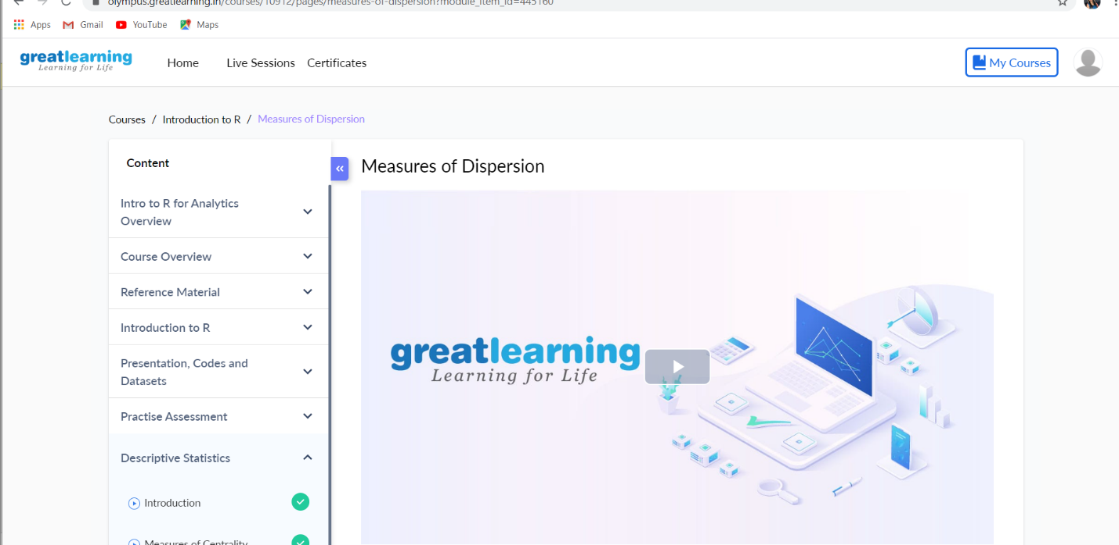

Coding

1. [C Programming if statement](https://beginnersbook.com/2014/01/c-if-statement/)
2. [C Programming if..else statement](https://beginnersbook.com/2014/01/c-if-else-statement-example/)

#include <stdio.h>

int main()

{

char ch;

bool isVowel = false;

printf("Enter an alphabet: ");

scanf("%c",&ch);

if(ch=='a'||ch=='A'||ch=='e'||ch=='E'||ch=='i'||ch=='I'

||ch=='o'||ch=='O'||ch=='u'||ch=='U')

{

isVowel = true;

}

if (isVowel == true)

printf("%c is a Vowel", ch);

else

printf("%c is a Consonant", ch);

return 0;

}

Output:

Enter an alphabet: E

E is a Vowel